# Lab: Intro and Basic Syntax

Problems for in-class lab for the ["C# Fundamentals" course @ SoftUni](https://softuni.bg/trainings/3729/programming-fundamentals-with-csharp-may-2022)  
You can check your solutions in [Judge](https://judge.softuni.org/Contests/1188/Basic-Syntax-Conditional-Statements-and-Loops-Lab)

## Student Information

Create a program that receives 3 lines of input:

* student name
* age
* average grade.

Your task is to print all of the info about the student in the following format: "Name: {student name}, Age: {student age}, Grade: {student grade}".

### Examples

|  |  |
| --- | --- |
| **Input** | **Output** |
| John  15  5.40 | Name: John, Age: 15, Grade: 5.40 |
| Steve  16  2.50 | Name: Steve, Age: 16, Grade: 2.50 |
| Marry  12  6.00 | Name: Marry, Age: 12, Grade: 6.00 |

## Passed

Create a program that receives a single number as an input representing a grade.

Print in the console:

* "**Passed!**" if the grade is **equal or more than 3.00.**

### Input

The **input** comes as a single floating-point number.

### Output

The **output** is either "**Passed!**" if the grade is **equal or more than 3.00**, otherwise you should print nothing.

### Examples

|  |  |  |  |  |
| --- | --- | --- | --- | --- |
| **Input** | **Output** |  | **Input** | **Output** |
| 5.32 | Passed! |  | 2.34 | *(no output)* |

### Solution

We need to take as an input a floating-point number from the console. We will use double.Parse() to convert **string** to **double**, which we receive from Console.ReadLine(). After that, we compare the grade with **3.00** and print the result **only** **if** the condition returns **true**.

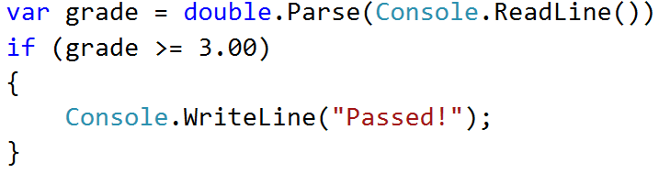

## Passed or Failed

Modify the program from the previous problem, so it will print "**Failed**!", if the grade is **lower than 3.00**.

### Input

The **input** comes as a single double number.

### Output

The **output** is either "**Passed**!" if the grade is **more than 2.99**, otherwise you should print "**Failed**!".

### Examples

|  |  |  |  |  |
| --- | --- | --- | --- | --- |
| **Input** | **Output** |  | **Input** | **Output** |
| 5.32 | Passed! |  | 2.36 | Failed! |

### Solution

We start by reading a **floating-point** number from the console. Next, we print in the **else** statement the appropriate message.

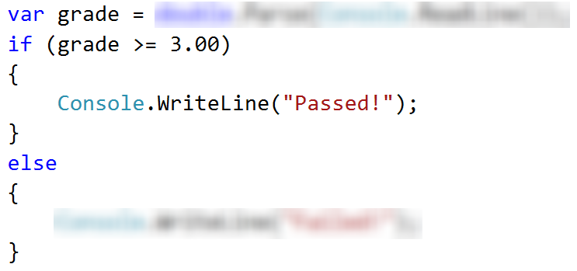

## Back in 30 Minutes

Every time John tries to pay the bills he sees on the cash desk the sign: **"I will be back in 30 minutes"**. One day John was tired of waiting and decided he needed a program, which **prints the time** after **30** **minutes**, so he could come back after exactly **30** **minutes**. He is not able to write the program by himself, so he asks for help.

### Input

Two numbers are read from the console:

* **The first** **number** is **hours** and will bebetween **0 and 23**.
* **The second number** is **minutes** and willbe between **0 and 59**.

### Output

Print on the console the time after **30** minutes. The result should be in format **hh:mm**. The **hours may** contain **one or two** **numbers** and the **minutes** always have **two numbers (with leading zero)**.

### Examples

|  |  |  |  |  |  |  |  |  |  |  |  |  |  |
| --- | --- | --- | --- | --- | --- | --- | --- | --- | --- | --- | --- | --- | --- |
| **Input** | **Output** |  | **Input** | **Output** |  | **Input** | **Output** |  | **Input** | **Output** |  | **Input** | **Output** |
| 1  46 | 2:16 |  | 0  01 | 0:31 | 23  59 | 0:29 |  | 11  08 | 11:38 |  | 11  32 | 12:02 |

### Hints

* Add 30 minutes to the initial minutes, which you receive from the console. If the minutes are more than 59, increase the hours by 1 and decrease the minutes by 60. In the same way, check if the hours are more than 23. When you print check for leading zero.

## Month Printer

Create a program that receives an **integer** and prints the matching **month**. If the number **is more than 12** or **less than 1**, print "**Error!**".

### Input

You will receive a **single** **integer** on a **single line**.

### Output

If the number is within the boundaries, print the corresponding month, otherwise print **"Error!"**.

### Examples

|  |  |  |  |  |
| --- | --- | --- | --- | --- |
| **Input** | **Output** |  | **Input** | **Output** |
| 2 | February |  | 13 | Error! |

### Solution

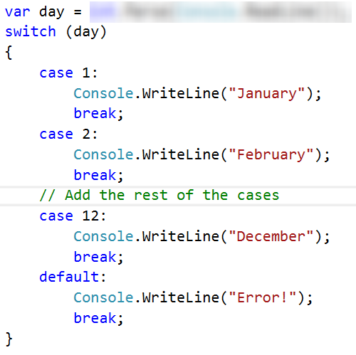

## Foreign Languages

Create a program that prints the spoken language in a country. You will receive only the following combinations:

* English **is spoken** in England and the USA.
* Spanish **is spoken** in Spain, Argentina, and Mexico.
* For the others**,** we should print "**unknown**".

### Input

You will receive a single line of input, representing the **country name**.

### Output

**Print** the **language** that is spoken in the given country. In case the country is **unknown** for the program, print **"**unknown**"**.

### Examples

|  |  |  |  |  |
| --- | --- | --- | --- | --- |
| **Input** | **Output** |  | **Input** | **Output** |
| USA | English |  | Germany | unknown |

### Hint

Think about how you can **merge** multiple cases, to **avoid** writing more code than you need to.

## Theatre Promotions

A theatre **sails tickets at discount** and a program is neededto **calculate** the price of a single ticket. If the given age does not fit one of the categories**,** you should print "**Error!**".

The prices of the tickets are as follows:

|  |  |  |  |
| --- | --- | --- | --- |
| **Day / Age** | **0 <= age <= 18** | **18 < age <= 64** | **64 < age <= 122** |
| **Weekday** | 12$ | 18$ | 12$ |
| **Weekend** | 15$ | 20$ | 15$ |
| **Holiday** | 5$ | 12$ | 10$ |

### Input

The input comes in **two lines**. On the **first** line you will receive the **type of day**. On the **second** – the **age** of the person.

### Output

Print the price of the ticket according to the table or "**Error!**", if the age is not in the table.

### Constraints

* The age will be in the interval **[-1000…1000]**.
* The type of day will **always be** **valid**.

### Examples

|  |  |  |  |  |  |  |  |  |  |  |
| --- | --- | --- | --- | --- | --- | --- | --- | --- | --- | --- |
| **Input** | **Output** |  | **Input** | **Output** |  | **Input** | **Output** |  | **Input** | **Output** |
| Weekday  42 | 18$ |  | Holiday  -12 | Error! | Holiday  15 | 5$ |  | Weekend  122 | 15$ |

### Solution

#### Step 1. Read the Input

We need to read **two** lines. The **first** one will be the **type of day**. We will convert it to **lower case** letters with the method "**ToLower()**". After that, we will read the **age** of the person and declare a **variable** – **price**, which we will use to set the price of the ticket.

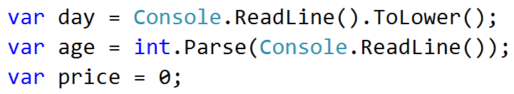

**Step 2. Add If-else Statements for the Different Types of Day**

For every **type of day**, we will need to add **different cases** to check the **age** of the person and **set the price**. Some of the **age groups** have **equal** **prices** for the **same type** of day. This means we can use **logical operators** to **merge some of the conditions**.

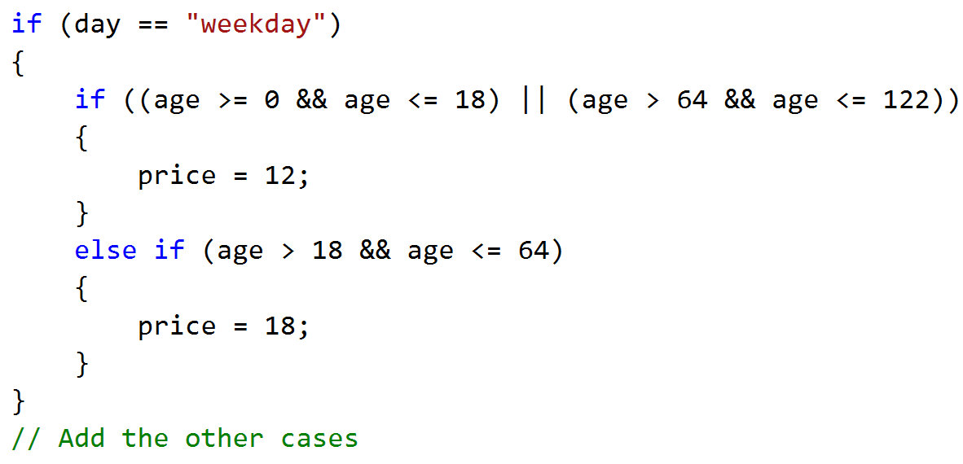

Think **where** and **how** you can use **logical operators** for the **other cases**.

**Step 3. Print the Result**

We can check if the price has a value different than the initial one. If It does, that means we got a valid combination of day and age, and the price of the ticket is saved in the price variable. If the price has a value of 0, then none of the cases got hit, therefore we have to print the error message.

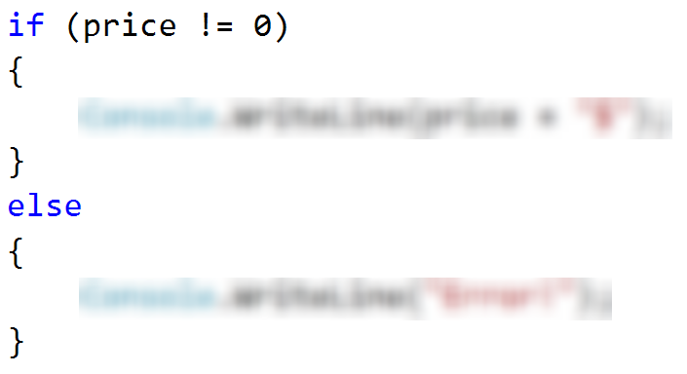

## Divisible by 3

Create a program, which prints all the numbers from 1 to 100, that are divisible by 3. You have to use a single for loop. The program should not receive input.

### Solution

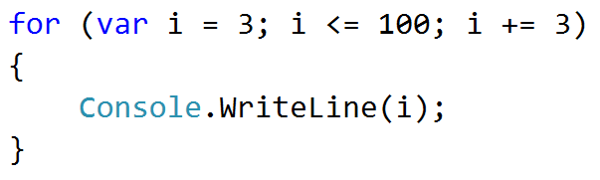

## Sum of Odd Numbers

Create a program that prints on a new line the next **n** **odd numbers** (starting from 1). On the **last row** print the **sum of all n odd numbers**.

### Input

A single number n is read from the console, indicating how many odd numbers need to be printed.

### Output

Print the next **n** odd numbers, starting from **1**, separated by **new lines**. On the last line, print the **sum** of these numbers.

### Constraints

* **n** will be in the interval **[1…100]**

### Examples

|  |  |  |  |  |
| --- | --- | --- | --- | --- |
| **Input** | **Output** |  | **Input** | **Output** |
| 5 | 1  3  5  7  9  Sum: 25 |  | 3 | 1  3  5  Sum: 9 |

### Solution

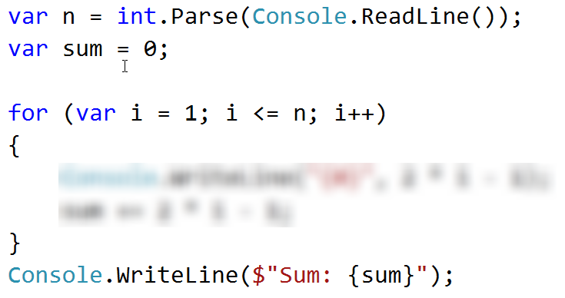

## Multiplication Table

Create a program that receives an **integer** as an input. Print the **10 times table** for this integer. See the examples below for more information.

### Output

Print every row of the table in the following format:

{theInteger} X {times} = {product}

### Constraints

* The integer will be in the interval **[1…100]**

### Examples

|  |  |  |  |  |
| --- | --- | --- | --- | --- |
| **Input** | **Output** |  | **Input** | **Output** |
| 5 | 5 X 1 = 5  5 X 2 = 10  5 X 3 = 15  5 X 4 = 20  5 X 5 = 25  5 X 6 = 30  5 X 7 = 35  5 X 8 = 40  5 X 9 = 45  5 X 10 = 50 |  | 2 | 2 X 1 = 2  2 X 2 = 4  2 X 3 = 6  2 X 4 = 8  2 X 5 = 10  2 X 6 = 12  2 X 7 = 14  2 X 8 = 16  2 X 9 = 18  2 X 10 = 20 |

## Multiplication Table 2.0

Rewrite the program from the previous task so it can receive the **multiplier from the console**. Print the **table with the multiplier** in the interval from **the given number to 10**. If the given multiplier is **more than 10**, print only one row with the **integer**, the given **multiplier,** and the **product**. See the examples below for more information.

### Output

Print every row of the table in the following format:

{theInteger} X {times} = {product}

### Constraints

* The integer will be in the interval **[1…100]**

### Examples

|  |  |  |  |  |  |  |  |
| --- | --- | --- | --- | --- | --- | --- | --- |
| **Input** | **Output** |  | **Input** | **Output** |  | **Input** | **Output** |
| 5  1 | 5 X 1 = 5  5 X 2 = 10  5 X 3 = 15  5 X 4 = 20  5 X 5 = 25  5 X 6 = 30  5 X 7 = 35  5 X 8 = 40  5 X 9 = 45  5 X 10 = 50 |  | 2  5 | 2 X 5 = 10  2 X 6 = 12  2 X 7 = 14  2 X 8 = 16  2 X 9 = 18  2 X 10 = 20 |  | 2  14 | 2 X 14 = 28 |

## Even Number

Create a program that reads a sequence of numbers. If the number is even, **print its absolute value in the following format: "The number is: {number}"** and **terminate** the program**.** If the number is odd, print "**Please write an even number.**" and continue reading numbers.

### Examples

|  |  |  |  |  |
| --- | --- | --- | --- | --- |
| **Input** | **Output** |  | **Input** | **Output** |
| 1  3  6 | Please write an even number.  Please write an even number.  The number is: 6 |  | -6 | The number is: 6 |

## Debug the Code: Holidays Between Two Dates

You are assigned to find and fix all bugs in the existing code. By using the Visual Studio debugger, place a breakpoint and find the lines of code that produce incorrect or unexpected results.

You are given a program (existing **source code**) that aims to **count the non-working days between two dates** in format day.month.year (e.g. between **1.05.2015** and **15.05.2015** there are **5** non-working days – Saturday and Sunday).

### Examples

|  |  |  |
| --- | --- | --- |
| **Input** | **Output** | **Comments** |
| 1.05.2016  15.05.2016 | 5 | There are 5 non-working days (Saturday / Sunday) in this period: 1-May-2016, 7-May-2016, 8-May-2016, 14-May-2016, 15-May-2016 |
| 1.5.2016  2.5.2016 | 1 | Only 1 non-working day in the specified period: 1.05.2016 (Sunday) |
| 15.5.2020  10.5.2020 | 0 | The second date is before the first. No dates in the range. |
| 22.2.2020  1.3.2020 | 4 | Two Saturdays and Sundays:   * 22.02.2020 and 23.02.2020 * 29.02.2020 and 1.03.2020 |

You can **find the broken code** in the judge system: [Broken Code for Refactoring](http://softuni.bg/downloads/svn/soft-tech/Sep-2016/Programming-Fundamentals-Sep-2016/03.%20Programming-Fundamentals-Methods-Debugging-and-Troubleshooting-Code/03.Programming-Fundamentals-Methods-and-Debugging-Lab-Broken-Solutions.zip). It looks as follows:

|  |
| --- |
| HolidaysBetweenTwoDates.cs |
| using System;  using System.Globalization;  class HolidaysBetweenTwoDates  {  static void Main()  {  var startDate = DateTime.ParseExact(Console.ReadLine(),  "dd.m.yyyy", CultureInfo.InvariantCulture);  var endDate = DateTime.ParseExact(Console.ReadLine(),  "dd.m.yyyy", CultureInfo.InvariantCulture);  var holidaysCount = 0;  for (var date = startDate; date <= endDate; date.AddDays(1))  if (date.DayOfWeek == DayOfWeek.Saturday &&  date.DayOfWeek == DayOfWeek.Sunday) holidaysCount++;  Console.WriteLine(holidaysCount);  }  } |

### Hints

There are **4** **mistakes** in the code. You've got to **use the debugger** to find them and fix them. After you do that, submit your **fixed code in the judge** [**contest**](https://judge.softuni.org/Contests/Practice/Index/1188#12).